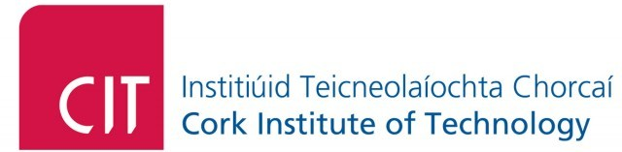

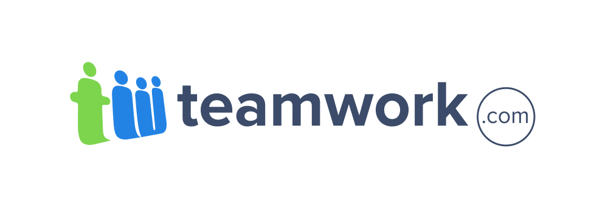

#### **ABOUT TEAMWORK**

Based in Cork, Ireland, Teamwork.com is a suite of business applications. Our flagship product, Teamwork Projects is an online project management software application that helps teams work together more productively online. Designed to help users manage their day to day projects either in a company or personal setting. Teamwork.com was set up to make managing your projects easy. The Web-based collaboration allows you to neatly manages milestones, time and tasks. Teams and clients can then all interact online in the one space.

**Industrial Mentor**

Name : **Michael "MJ" Heffernan**

Role: Support Specialist

Likes : MJ LIKES MEAT, TV AND TALKING

About: While I am nowhere near as technical-minded as the guys, I wouldn’t know the difference between Java or JavaScript (same thing isn’t it?), I do love technology and relish the chance to learn something new every day

### *Summary*

Teamwork.com is the backbone behind the world’s most productive teams. Right now while you’re reading this nearly 1.5m users are going about their daily business, using Teamwork

Project Manager to collaborate and coordinate all their work - how awesome is that!

Every day we come to work to build the very best products for our customers - they’re all that matter to us - we’re a privately owned company, with no investors to worry about so we focus on what matters - customers, customers, customers.

We’re always looking out for new talent and new people and figure that the easiest way to find them is to open our doors and let people in to see what they make of the truly unique work environment that we’ve built here.

We are looking for someone who is enthusiastic and wants to work with the Web. Someone willing to learn - we encourage a “Come see what I did” attitude. We’re far more interested in what you did in your spare time than what you were taught in college, or more importantly how you’ve applied the knowledge you gained in college to work on practical projects that will impress us.

Self motivation and the ability to work on your own initiative is very important for any placement at Teamwork. We believe in staying out of our people’s way so while we’ll be there to help, guide and point, you’ll be given real work of substance to do so that you can make a direct and valuable contribution towards growing our platform.

#### 